DATED THIS DATE

BETWEEN

TimeTec Computing Sdn Bhd
(Company Registration No.:922870-T)

AND

CUSTOMER COMPANY
NAME

###################################################################

SOFTWARE & HARDWARE SUPPORT AGREEMENT

###################################################################

TimeTec Computing Sdn Bhd

No 6, 8 & 10, Jalan BK3/2, Bandar Kinrara
47100 Puchong, Selangor Darul Ehsan
Malaysia
Tel: 03-80709933
Fax: 03-80709988

( File Ref: )

TimeTec Computing Sdn Bhd (Company Registration No.:922870-T) a company registered in Malaysia and having its business address at No 6, 8 & 10, Jalan BK3/2, Bandar Kinrara, 47100 Puchong, Selangor Darul Ehsan, Malaysia. (hereinafter referred as “TimeTec”) of the one part.

AND

CUSTOMER COMPANY NAME, a company incorporated in Malaysia and having its business address at CUSTOMER COMPANY ADDRESS. (hereinafter referred as “Customer”) of the other part.

WHEREAS the Customer is desirous of having Software & Hardware Support Services for the Software & Hardware as listed in SCHEDULE A attached hereto and TimeTec agrees to render the Software & Hardware Support Services on the Software & Hardware, subject to the terms and conditions set forth in this Agreement.

AND WHEREAS the Agreement and all the schedules referred herein shall specify the scope of the Software & Hardware Support Services which shall be provided during the duration of this Agreement.

NOW IT IS HEREBY AGREED AS FOLLOWS :-

1. SERVICE

1.1 TimeTec agrees to render Software & Hardware Support Services as described in Clauses 3 and 4 below (hereinafter referred to as "Software & Hardware Support Services") to the Customer and the Customer agrees to accept the Software & Hardware Support Services by TimeTec on the Cloud based Software & Hardware and Fingertec Terminal described in SCHEDULE A attached hereto (hereinafter referred to as the "Software & Hardware"), subject to the terms and conditions hereinafter stated.

1.2 Software & Hardware Support Services shall be rendered by TimeTec at the Service Address as described in SCHEDULE B attached hereto.

2. TERMS OF SOFTWARE & HARDWARE SUPPORT SERVICES AND AGREEMENT

2.1 Software & Hardware Support Services shall commence on the expiry date of the preceding year’s Software & Hardware Support Agreement between the Parties i.e., DATE STARTED (hereinafter referred to as "Commencement Date").

2.2 Unless this Agreement is terminated in accordance with Clause 10, Software & Hardware Support Services to the Software & Hardware shall continue up to DATE END (hereinafter referred to as "Term of Software & Hardware Support").

2.3 In the event that any of the Parties desires to terminate Software & Hardware Support Services to the Software & Hardware upon the expiration of the Term of Software & Hardware Support, such party shall notify the other in writing at least one (1) calendar month prior to the expiration of such Term of Software & Hardware Support. If such Software & Hardware Support Services is not terminated upon the lapse of the Term of Software & Hardware Support, it shall be deemed automatically extended and shall be in full force and effect on a year to year basis until either of the Parties notifies the other in writing of its intention to terminate such Software & Hardware Support Services at least one (1) calendar month prior to the intended date of termination provided always that TimeTec and the Customer shall have agreed on the fees payable for each such renewed term.

2.4 This Agreement shall become effective on the Commencement Date hereof and shall remain in force and effect for as long as TimeTec continues its Software & Hardware Support Services to at least any one model of the Software & Hardware, subject to the provisions of Clause 10.1.

3. SOFTWARE & HARDWARE SUPPORT SERVICE

3.1 TimeTec shall provide the Customer with Software & Hardware Support Services which shall consists of General and Remedial Software & Hardware Support Services as defined in Clause 3.1(a), (b) and (c) below designed to ensure that the Software & Hardware remains error free and in conformity with the Operating Specifications and with the warranted performance criteria referred to in Software & Hardware Licence Agreement. The operation hours coverage are specified in Schedule C.

(a) The General Software & Hardware Support Services by TimeTec to remedy any defect or error complained by the Customer shall include provision of the following services promptly on request:-

3.1.1 telephone support in the form of consultation, assistance and advice; or

3.1.2 e-mail support at the option of the Customer.

if such telephone and/or e-mail support fails to remedy any defect or error complained by the Customer, Remedial Software & Hardware Support Services i.e correction of errors or defects of the Software & Hardware at the site shall be rendered to Customer, so far as it is reasonably practicable to restore and correct the Software & Hardware's malfunction.

3.1.3 Training necessitated by such advice and corrections.
(b) The response time for General Software & Hardware Support Services from qualified technical personnel is 2 hours.

(c) Upon receipt of a request for Remedial Software & Hardware Support, TimeTec shall provide a suitably qualified Support engineer with totally familiar with the Software & Hardware at the site and subject to unforeseeable delays, within four (4) hours of request, or the next morning if request for engineer beyond office working hours. Working hour shall be Monday to Friday, 9AM to 6PM, excluding public holiday.

3.2 TimeTec shall classify and handle the malfunction in accordance with the following definitions:

(a) Class A malfunction means a malfunction that prevents a piece of functionality within the Software & Hardware from operating and prevents the Software & Hardware from being utilized in a live production environment for which no acceptable workaround is available. These malfunctions are recurring or catastrophic problems with no alternatives, they affect security, integrity or data access or require/cause system reboots. They do not permit the Customer to normally track employee’s time attendance. TimeTec shall, within sixty (60) minutes of receiving a logged communication, respond to Customer via telephone and/or email.

(b) Class B malfunction means a malfunction within the Software & Hardware which causes a serious or significant operational impact which, due to its nature, does not stop tracking employee’s time attendance. This may also include intermittent malfunctions and problems that cause serious inconvenience to the Customer. These malfunctions mean that the data of a employee is risks being stopped and/or the whole clocking cycle is late.
TimeTec shall, within four (4) hours of receiving a logged communication, respond to the Customer via telephone and/or email.

- Class C malfunction means a malfunction of the Software & Hardware which creates no, or minimal, operational impact and does not prevent the use of the Software & Hardware in live production. Typically these malfunctions are cosmetic and can be simply worked around and overcome. These malfunctions will be remedied by mutual agreement of the parties. TimeTec shall, within forty-eight (48) hours of receiving a logged communication, contact the Customer via telephone and/or email.

4. SOFTWARE & HARDWARE UPGRADE

The system will automatically update when we update the software, it is completely free for every update and latest update will also be available immediately.

The updates of our software are done two to four times in a month. The updates include adding new functions, system and feature enhancements. The new features will be announced monthly in: http://www.timetecta.com/feature/

5. EXCLUSIONS

5.1 Software & Hardware Support Services covered by this Agreement shall not include the following:

(a) Maintenance of accessories, attachments, machines, or other devices not supplied by TimeTec or FingerTec;

(b) Re-installation, moving or removing the Software & Hardware, devices or attachments;

(c) Service calls made necessary by accident, misuse, fault or negligence of the Customer, its employees, agents, contractors or invitees, Customer program or operator error, alterations of the Software & Hardware, interconnection to the Software & Hardware of other Software & Hardware not supplied by TimeTec;

(d) Correction of errors or defects caused by operation of the Software & Hardware in a manner other than that expressly or by implication authorized by the TimeTec;

(e) Rectification of errors caused by misuse or incorrect use of the Software & Hardware by the Customer;

5.2 If the Customer requests in writing TimeTec may provide any of the services referred to in Clause 5.1. TimeTec shall be entitled to levy additional charge for such services.

6. Associated Documentation

6.1 If correction of errors or faults in the Software & Hardware necessitates an amendment to the Associated Documentation as defined in the Software & Hardware License Agreement, TimeTec shall supply copies of the amended documentation to the Customer within thirty (30) days of discovery by TimeTec or Customer (whichever is the earlier) of the need for amendment.

6.2 TimeTec shall amend the Associated Documentation within thirty (30) days of being notified by the Customer that it is inadequate or inaccurate. TimeTec shall supply two (2) copies of the amended documentation within thirty (30) days of the Customer’s notification.

7. CHARGES

7.1 Yearly Support Charges for the Software & Hardware shall commence on the Commencement Date specified for the Software & Hardware listed in SCHEDULE A attached hereto and are payable to TimeTec in accordance to Schedule D as long as this Agreement remains in force.

7.2 The Support Charges specified in SCHEDULE D shall remain in effect up to DATE END. TimeTec may change charges annually thereafter on ninety (90) days prior written notice to the Customer. Any increase made by TimeTec pursuant to this clause shall not exceed three per cent (2%) of the charges paid by the Customer to TimeTec in the year immediately preceding the commencement of the proposed increase. If TimeTec notifies the Customer of a proposed increase in the Support Charges in accordance with this sub-clause, the Customer may at its option accept the proposed increase, or terminate the Software & Hardware Support Services to which the charges relate. The Customer must provide thirty (30) days, notice of intention to terminate pursuant to this sub-clause, which notice will be ineffective if TimeTec withdraws the proposed increase or modifies the proposed increase to the satisfaction of the Customer.

7.3 All charges relating to items in Clauses 5.2, if performed by TimeTec shall be billed to the Customer at TimeTec's standard rates in effect at the time.

7.4 All charges in arrears shall bear interest at the rate of 6% per year from the date they become due until the outstanding charges are fully paid.

7.5 All payments to TimeTec shall be made including Goods and Services Tax imposed by the Government of Malaysia, which shall be borne and paid by the Customer.

8. ACCESS TO SOFTWARE & HARDWARE

Subject to security regulations of the Customer, employees of TimeTec shall have access to the Software & Hardware at all reasonable times solely for the purpose of rendering the Software & Hardware Support Services under this Agreement.

9. ADDITIONS AND DELETIONS

By addendum signed by the parties hereto, both parties can either add or delete certain modules of the Software & Hardware from SCHEDULE A, subject to appropriate adjustment to TimeTec's then applicable prices and other terms then in effect. These adjustments will be set out in such addendum which addendum shall have effect as if it were incorporated into this Agreement.

10. TERMINATION

10.1 TimeTec shall have the right on written notice to terminate this Agreement if the Customer, within thirty (30) days after the receipt of a reminder, fails to make payments due.

10.2 Without prejudice to any other rights that the Customer may have under this Agreement, the Customer may terminate the Agreement immediately by notice in writing if TimeTec is in breach of any clause of this Agreement and such breach is not remedied within thirty (30) days of written notice by the Customer. If notice is given to TimeTec to terminate this Agreement, the Customer may, in addition to terminating this Agreement recover any sums paid to TimeTec for Software & Hardware Support Services which have not been fulfilled or performed.

10.3 Any money due and owing shall become immediately payable unless the Customer alleges breach of this Agreement by TimeTec. The obligations of either party which have already accrued at the time of termination of this Agreement (including the obligations of payment) shall survive the termination of this Agreement.

11. LIMITATION OF LIABILITY

11.1 TimeTec expressly warrants that it shall carry out the Software & Hardware Support Services using reasonable care and skill in a professional manner conforming to generally accepted industry standards and practices. NO FURTHER WARRANTIES ARE GIVEN EXCEPT AS EXPRESSLY STATED. IN NO EVENT SHALL TIMETEC OR ANY OF ITS AGENTS BE LIABLE FOR ANY LOSS OF OR DAMAGE TO THE CUSTOMERS DATA, REVENUES, PROFITS OR GOODWILL OR OTHER SPECIAL, INCIDENTAL, INDIRECT AND CONSEQUENTIAL DAMAGES OF ANY KIND, RESULTING FROM ITS PERFORMANCE OR FAILURE TO PERFORM PURSUANT TO THE TERMS OF THIS AGREEMENT OR RESULTING FROM THE FURNISHING, PERFORMANCE, OF THE SOFTWARE & HARDWARE SUPPORT SERVICE HEREUNDER, INCLUDING WITHOUT LIMITATION ANY INTERRUPTION OF BUSINESS, WHETHER RESULTING FROM BREACH OF CONTRACT OR BREACH OF WARRANTY, EVEN IF TIMETEC HAS BEEN ADVISED OF THE POSSIBILITY OF SUCH DAMAGES.

11.2 Notwithstanding anything above to the contrary, the maximum aggregate amount of money damages for which TimeTec may be liable to the Customer under this agreement, resulting from any cause whatsoever, shall be limited to the amounts actually paid by Customer to TimeTec under this agreement

12. SUB-CONTRACTS

TimeTec shall arrange qualified personnels or shall has the right to sub-contract to qualified reseller to perform any of the Software & Hardware Support Services.

13. FORCE MAJEURE

If during the performance of this Agreement, a state of war whether declared or not in which the Customer and/or the government of country of origin is involved or affected, or any state of riot, civil commotions or general strike or any earthquake, flood or tempest arises or exists which has materially affected the fulfilment of the Agreement, the Customer's obligations under the Agreement shall cease.

14. CONFIDENTIALITY

TimeTec shall treat as confidential, information which comes into its possession, pursuant to or as a result of or in the performance of this Agreement, whether such information relates to the business, sales, marketing or technical operations of the Customer or the clientele of the Customer or otherwise.

TimeTec shall not, without the written permission of the Customer, disclose such confidential information to a third party.

The operation of this Clause shall survive the termination of this Agreement.

15. DISPUTE

15.1 Any dispute of a technical nature arising in connection with this agreement which cannot be settled by negotiation between the parties or their representatives shall be dealt with in the following manner:

15.1.1 the dispute shall be referred to a committee of three comprising the General Managers or Senior Vice President of each party and a third party nominated with the consent of both parties.

15.1.2 the quorum necessary for the making of decisions by the committee shall be three and each issue will be resolved by a majority of votes;

15.1.3 the committee will consider within seven (7) days any matter referred to it in writing by either party;

15.1.4 either party unsatisfied with the decision of the committee or the failure of the committee to make a decision may submit the dispute including any question regarding its existence, validity or termination shall be referred to and finally resolved by arbitration in Malaysia in accordance with the Malaysia International Arbitration Centre’s prevailing Domestic Arbitration Rules, subject to the Arbitration Act (Cap 10) and any modifications and re-enactment thereof for the time being in force. Such arbitration shall be conducted in English.

15.2 At all times during the preparation for, hearing of or deliberation over a dispute as referred to in clause 15.l.4, the parties shall to the extent possible proceed to complete their respective obligation under this agreement.

Nothing in this clause shall preclude either party from taking immediate steps to seek equitable relief before the appropriate court in Malaysia.

16. GENERAL PROVISION

16.1 The proper stamp duty, if any, on this Agreement shall be borne by the Customer.

16.2 Any notices or other communication required to be given hereunder by TimeTec to the Customer shall be in writing signed by TimeTec and shall be deemed to have been given if delivered by registered mail or by hand to the Customer’s registered office at CUSTOMER COMPANY ADDRESS.

16.3 Any notice or other communication required to be given hereunder by the Customer to TimeTec shall be in writing signed by or on behalf of the Customer and shall be deemed to have been given if delivered by registered mail or by hand to TimeTec's business address at No 6, 8 & 10, Jalan BK3/2, Bandar Kinrara, 47100 Puchong, Selangor Darul Ehsan, Malaysia.

16.4 In this Agreement where the context admits, the expression "TimeTec" shall mean TimeTec Computing Sdn Bhd, its successors and assigns and the expression "The Customer" shall mean the Customer and its successors.

16.5 Words importing the singular only shall also include the plural and vice-versa where the context requires.

16.6 The titles to the terms and conditions of this Agreement are for convenience of reference only, and are not part of this Agreement and shall not in any way affect the interpretation thereof.

16.7 The construction of this Agreement and any dispute relating thereto shall be governed by the laws of Malaysia and the parties submit to the non-exclusive jurisdiction of the courts of Malaysia.

(This Portion Is Intentionally Left Blank)

IN WITNESS WHEREOF the parties have hereunto set their hands the date and year first above written.

SIGNED by )
for and on behalf of the )
TIMETEC in the )
presence of:- ) ________________________
Name:

____________________________
Name:

SIGNED by )
for and on behalf of the )
CUSTOMER in the )
presence of:- ) __________________________
Name:

___________________________
Name:

SCHEDULE A

TIMETEC SOFTWARE & FINGERTEC HARDWARE (“The Software & Hardware ”)
Note: The Software & Hardware and its components covered under this agreement.

TimeTec TA

TimeTec TA is a cloud-based solution developed by TimeTec Computing Sdn Bhd to automate Time & Attendance management to suit most businesses. TimeTec TA is designed to help organizations reduce their administrative overheads by eliminating the time spent on manual timecard calculations, decrease overall labor costs, and to shrink the gap between payroll policy and actual practice.

The system is built on Microsoft .NET framework and MySQL Relational Database Management System for reliability and flexibility. Users can update and retrieve real-time information from anywhere in the world as long as there is Internet connection.

The system is delivered with a complete set of scheduling and time and attendance reports, which enable validation and reconciliation of electronic time sheets with payroll.

Besides sustaining multiple shifts, rotational shifts and overnight shifts, the system also supports up to an incredible 14-column of clocking schedules, 30- type reports which makes TimeTec TA a perfect web system for small & medium enterprises (SME) and multinational companies (MNC).

The basic workflow of TimeTec TA:
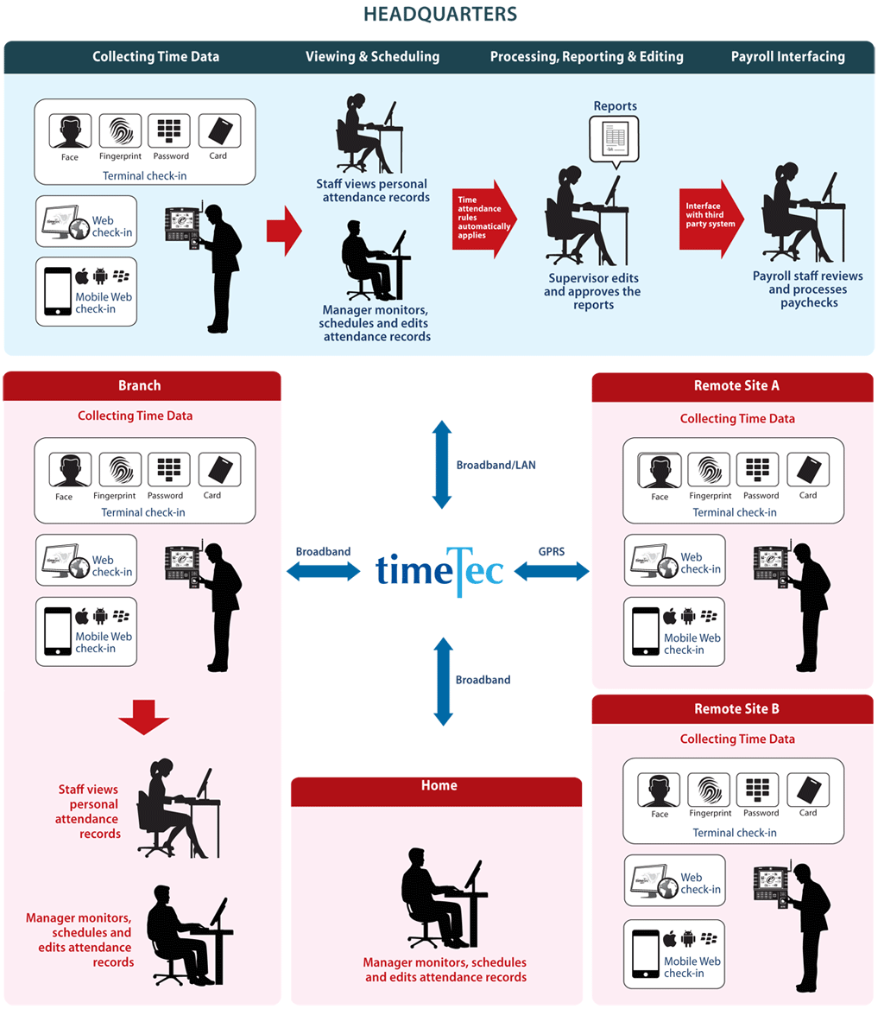

Efficiency is key in any business organization – mismanagement of employees’ time and effort will only hold a company back. The usage of advanced time clock devices coupled with an effective time attendance solution, such as FingerTec biometric terminals and TimeTec TA, will help your company operates at its full potential in the following ways:

TimeTec TA helps to:
- Centralizes All Clocking Data
- Provides Data Access to Connected PCs, Anytime
- Performs Comprehensive Functions in a Friendly UI
- Reduces Manual and Timely Admin Tasks
- Ensures Application of Work & Pay Rules
- Minimizes Compliance Risks Conveniently

TimeTec TA provides three types of clocking methods for users to record attendance data.
- Attendance Clocking via FingerTec Device
- Attendance Clocking via Smartphone with TimeTec Mobile App
- Attendance Clocking via PC with Web Clock-In

Attendance Clocking with FingerTec Device

FingerTec is an affiliate brand of TimeTec for fingerprint, face, card products for access control and time attendance products. FingerTec’s biometric devices work perfectly with TimeTec TA system because it has push technology that can push attendance data to TimeTec TA in real time. The benefits of using FingerTec’s biometric devices as attendance clocking input units are as follow:

- Minimizes Human Errors
- Enforce Pay and Attendance Policies
- Reduces Overall Cost, Maximizes Gain
- Operates Quickly and Conveniently

Attendance Clocking via Smartphone with TimeTec Mobile App

TimeTec Mobile is an App available in both iOS and Android platform. It comes as a part and parcel for TimeTec TA as an attendance clocking option for users, and also as an instant notification and monitoring tool. It is a real-time solution aimed at providing convenience and flexibility especially to industries that have staff who are constantly on-the-move, enabling them to report their attendance wherever they are. Supervisors as well can experience the convenience of tracking and enforcing attendance policies easier than before, as the TimeTec Mobile connects to the TimeTec server, allowing employees and superiors to use their Android or iPhone to clock-in their attendance, view attendance sheets and print out attendance reports.

Sample user interfaces for TimeTec Mobile App:
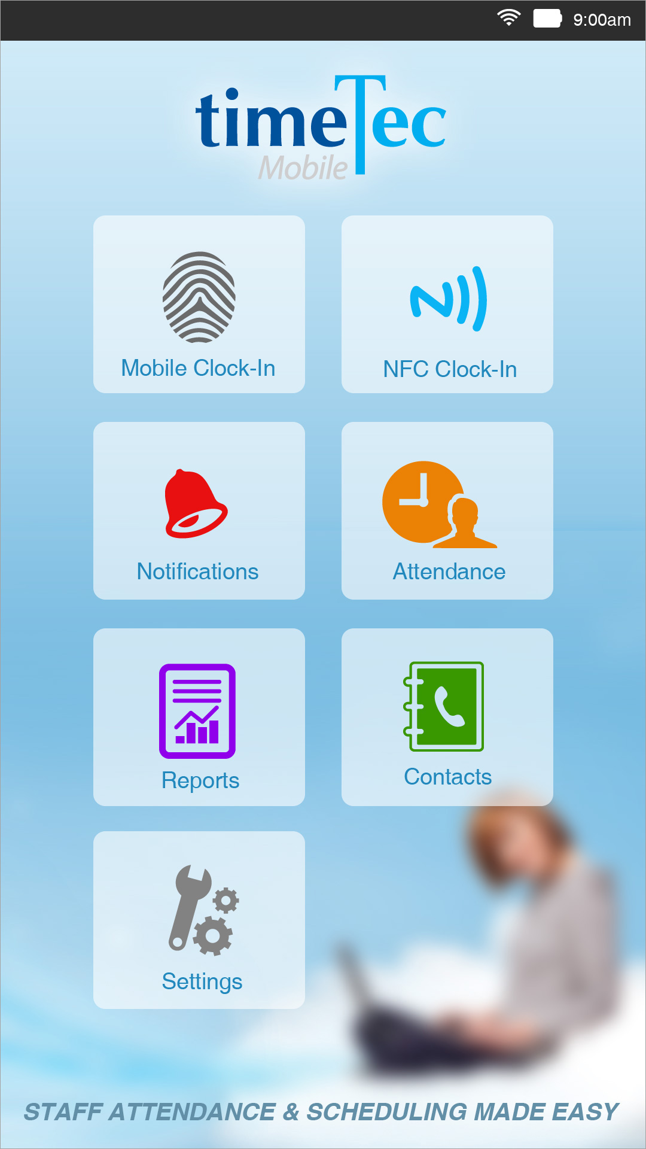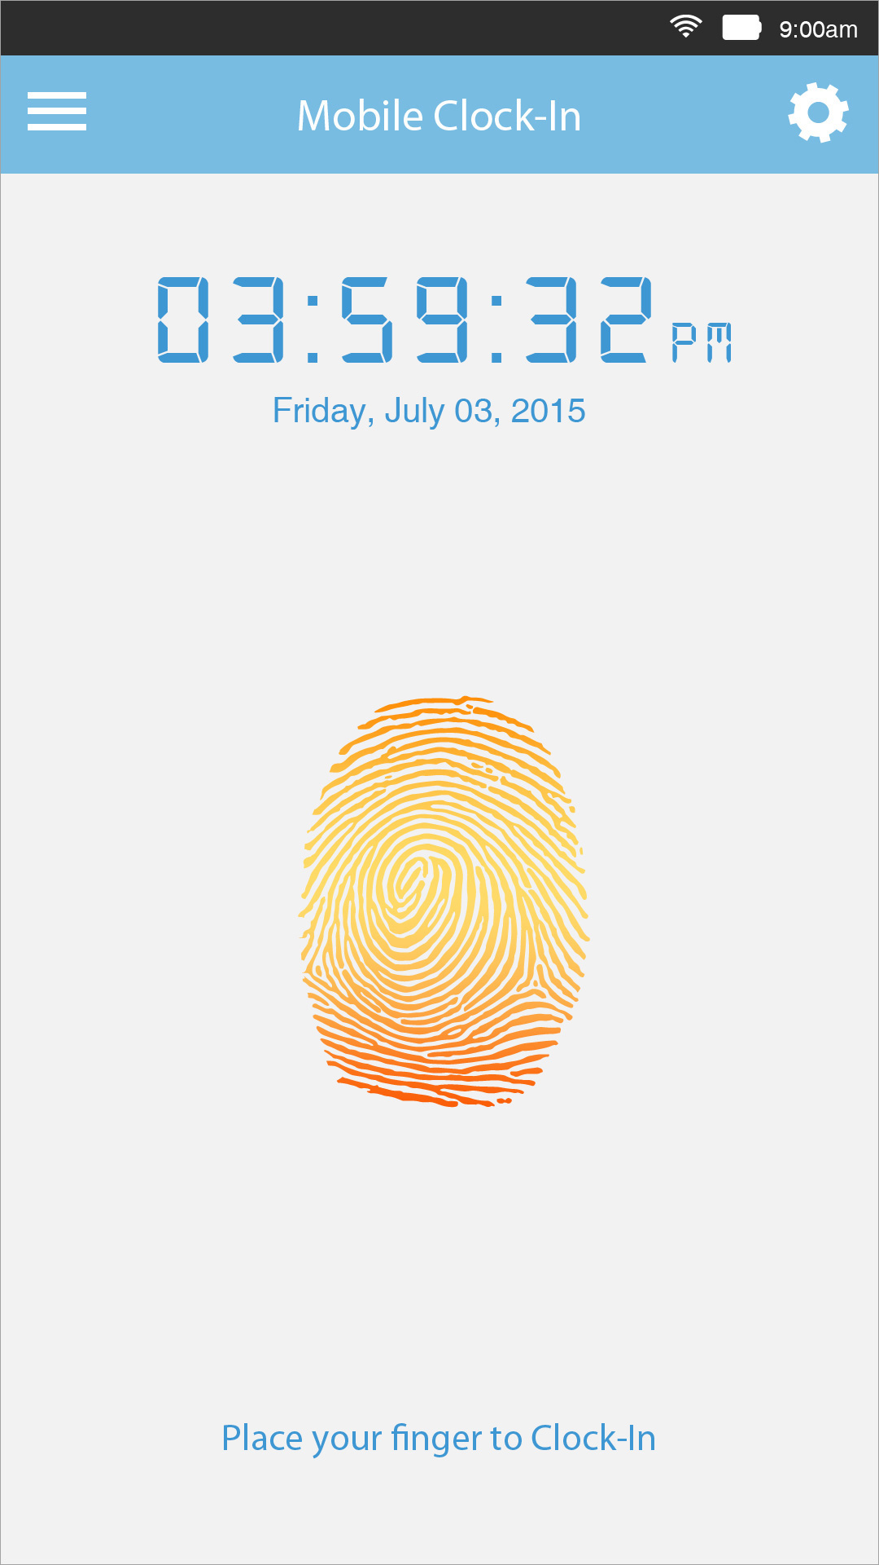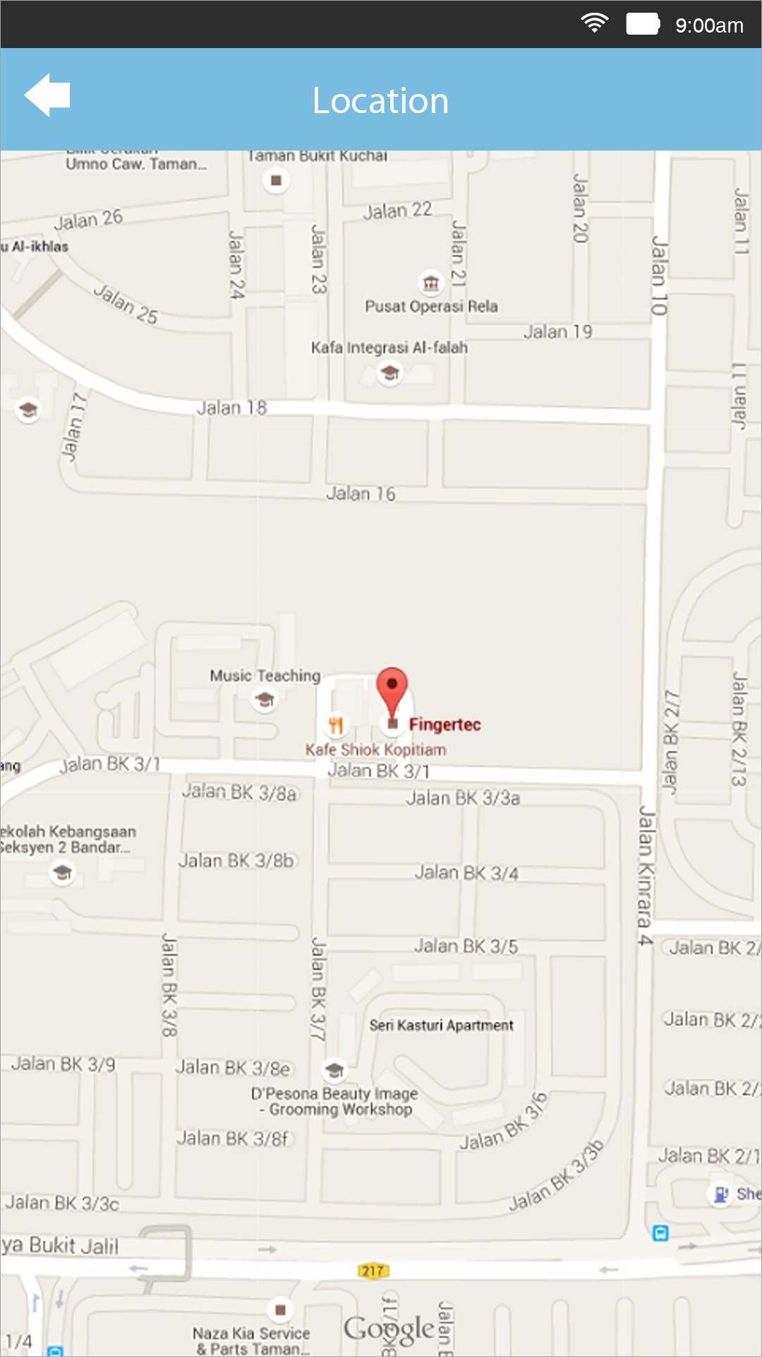

Attendance Clocking via PC with Web Clock In

For employees that are using a desktop or laptop computer, users can use TimeTec TA’s Web-Clock in feature that comes standard with TimeTec TA solution.

User interface for TimeTec Web Clock-in:
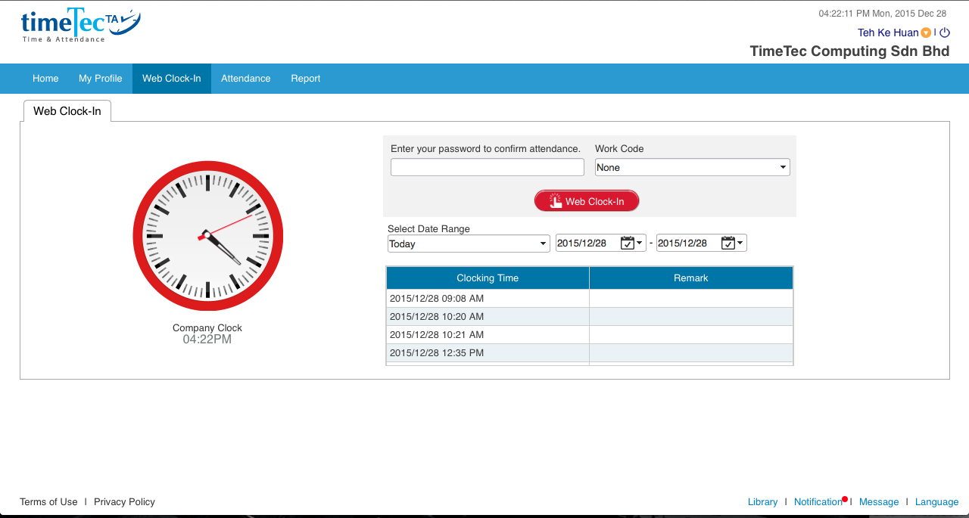

For further details of TimeTec TA, please refer to the following link: www.timetecta.com.

FingerTec Hardware TA100C Specifications
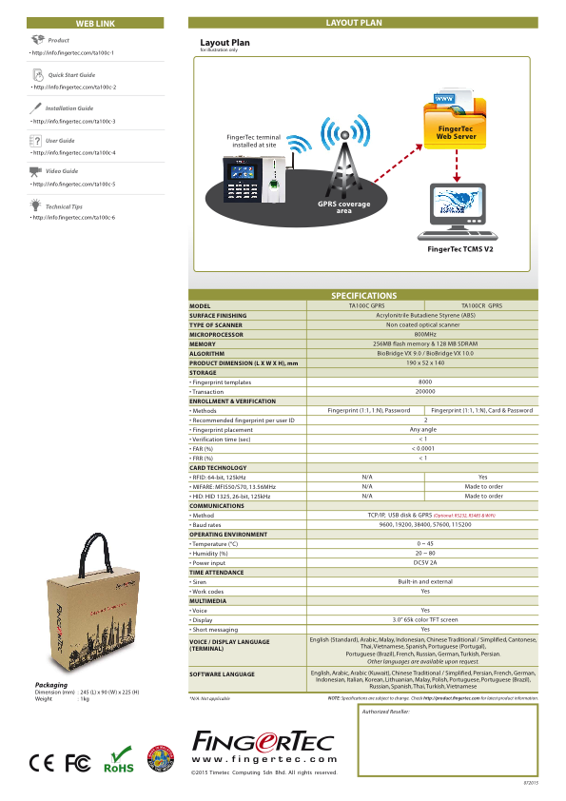

SCHEDULE B

SERVICE ADDRESS

NO. | SITE | SERVICE ADDRESS
1. | SITE-A
2. | SITE-B
3. | SITE-C

SCHEDULE C

COVERAGE HOURS

0900 hours to 1800 hours, Mondays to Fridays except Public Holidays.

SCHEDULE D

PRICE AND TERMS OF PAYMENT

(A) Price of Software & Hardware Support Services (for one-year of this Agreement)

PRICING (PRICING on softweare, PRICING on Hardware) , being 12% of the Price of the Licensed Software & Hardware (as more specifically set out in the Software & Hardware License Agreement).

(B) Payment Mode
Total Amount of the 12 months Software & Hardware Support Services Price shall be payable 30 days before the effective implementation date of the Software & Hardware Support Agreement.
Date of implementation: DATE STARTED
Total Amount: PRICING

